28 November 2019

Dear Parent/Carer

Unexplained Absences

I am writing to make you aware of the school procedure for children who have unexplained absences from school.

There have been public cases in the past where schools have not followed up the reasons as to why a child is absent from school. It has then transpired that there have been tragic circumstances around these absences, for example the illness of a parent and a child unable to seek help.

We will do everything we can to prevent such situations occurring as I am sure you would agree that your child’s safety is paramount to us all.

Therefore if your child is not going to be in school please call the office before 9 a.m. on 0208 462 1769 or send an email to admin@hayes-pri.bromley.sch.co.uk to report their absence.

If we have not heard from you by 9.30 a.m., we will start to call all the contact numbers that you have provided in order to gain an explanation for the absence. If we still have not been able to ascertain where your child is, then we will make a home visit. However, if we still haven’t been able to get a response, then we will report it to the police as your child will then be classed as a ‘missing child’.

This procedure is to ensure that we know where your child is and that you are all safe, so it is essential that you let us know in good time why your child is absent from school.

An absence MUST be reported every day until your child returns to school, even if this is a continued absence. When reporting the absence, please provide full details including symptoms of illness so it can be correctly recorded in our records. This ensures we can follow our Safeguarding procedures.

Thank you for your cooperation in this matter.

Yours sincerely
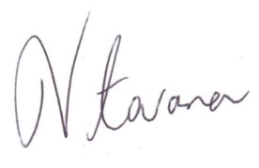
Mr Vitarana

