In Attendance
Jacqui Towne Chair
Edward Tory Secretary
Tracy Griffin Committee Member & Teacher Representative
Louise Field Committee Member & Teacher Representative
Ashley Irving Committee Member
Sarah Warner Committee Member

Members not in attendance
Claire McKeogh Treasurer
Claire Osborne Vice Chair
Gareth Rees Committee Member
James Gibson Committee Member
Justina Lee Myers Committee Member

Quorum

From the constitution:

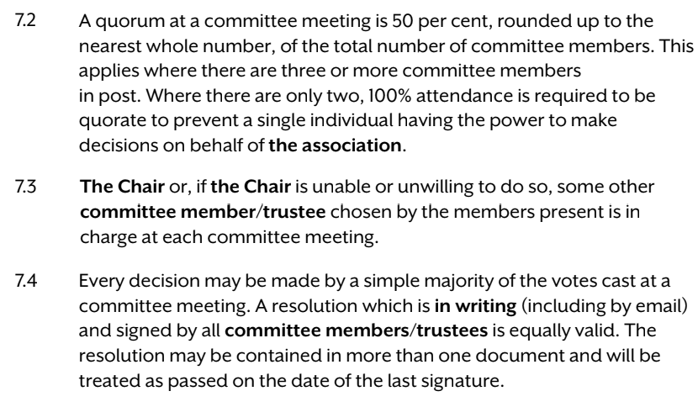

As such, with 6/11 members present, binding decisions can be agreed on behalf of the association through simple majority votes of those in attendance.

Funding Decisions:

- Library
Louise Field explained the desire for library spend to set up furniture etc. Cheapest quote was 5.5k, the most expensive was 12k. The best was 6.45k. The school would like to go ahead. Furniture can be moveable. Will be used for a phonics group every morning also, and each class has a slot every week.
Vote: £6,450 to pay for the library furniture.
6 voted in favour. Approved.
- Boombox.
Requested so that there will be one for each playground as the kids love them. It was questioned whether this needed a vote as it’s under £200, but voted regardless.
Vote: £150 for a new Boombox
6 voted in favour. Approved.

- Afford the school some flexibility on using the pledged money for Young Carers’ trips
Too many non-educational trips affect attendance records which is an issue. Want to take children to a London experience instead. Bigger trip rather than two smaller ones. School is going to do a once-a-month craft club for the YC also run by Miss Beadle, so it makes sense to have one bigger trip as they are getting regular activities already.
Vote: Flexibility on spending the YC money on one trip not two
6 voted in favour. Approved.

Future Funding Discussions
- KS2 Playground markings
KS1 playground markings have been a huge hit. Children really use it a lot and there has been lots of positive feedback from parents. However, parents are asking why KS2 doesn’t have the same thing and Teacher Representatives explained they’d like to replicate it if they can.
However, there are potential issues with the KS2 playground surface because it is older and in a worse state of repair so that may not work or last. It is a bigger space and may need to be totally re-surfaced don’t know yet. No point yet in further discussion until this is established.

Charity Trusteeship
From parentkind:
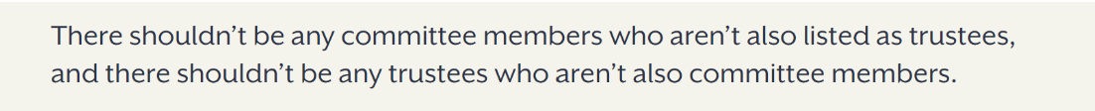
All committee members must become trustees with the charity commission.
Edward Tory and Claire McKeogh to arrange this.

Any Other Business
Previous committee meeting minutes from 19/09/2023 were signed by Jacqui Towne (Chair) and Louise Field (Teacher Representative)
Non-uniform days and car parking for Christmas fair – Ashley Irving to email and teachers to check with Headteacher.
Clarified that Lisa Field is not a committee member as she did not wish to be nominated.
Lots of wellies in the hut and lots of kids coming to school without them. Send a note out.

End of Meeting
Minutes recorded by Edward Tory as Secretary

