https://www.thinkuknow.co.uk/

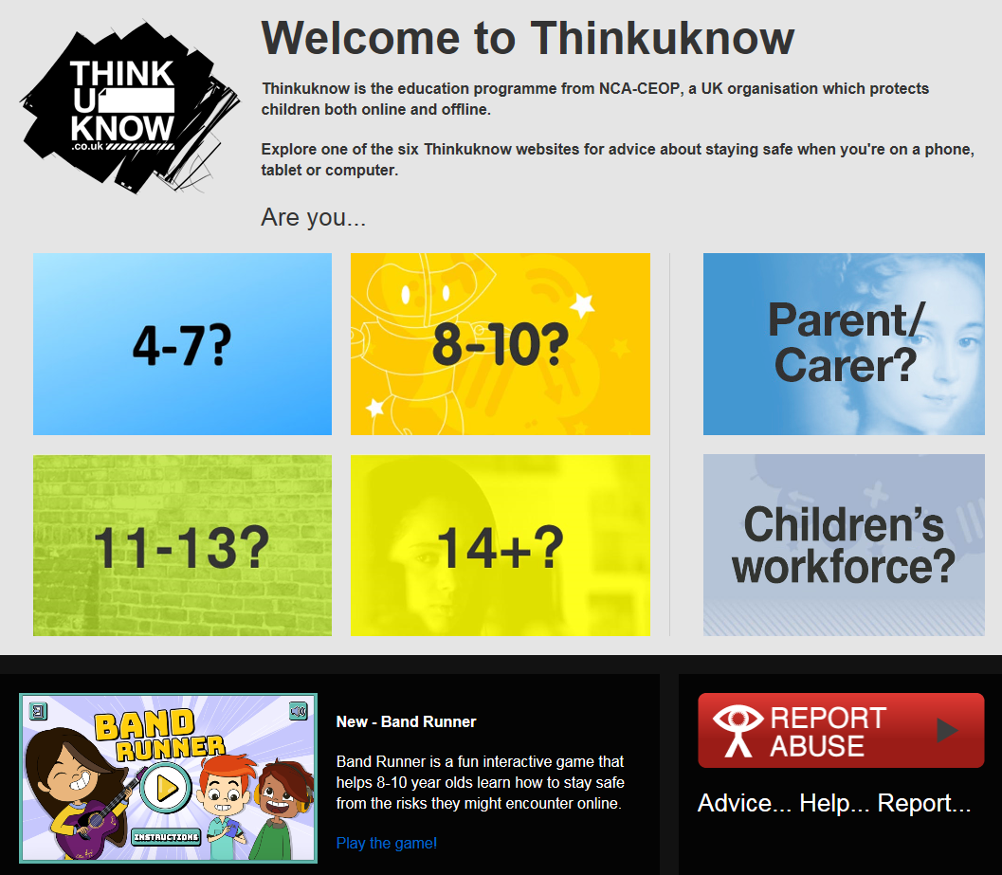

https://www.getsafeonline.org/
https://www.commonsensemedia.org/reviews
expert/parent/child reviews of games and films.
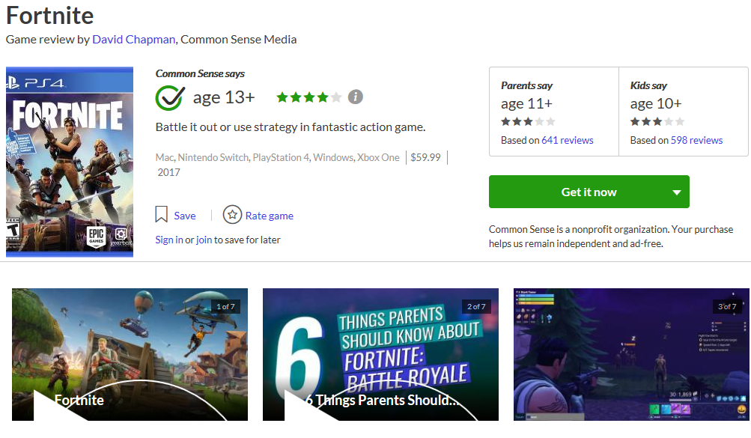

https://parentzone.org.uk/
Lots of articles written for parents on a wide range of subjects.



https://parentinfo.org/
Lots of articles written for parents on a wide range of subjects.
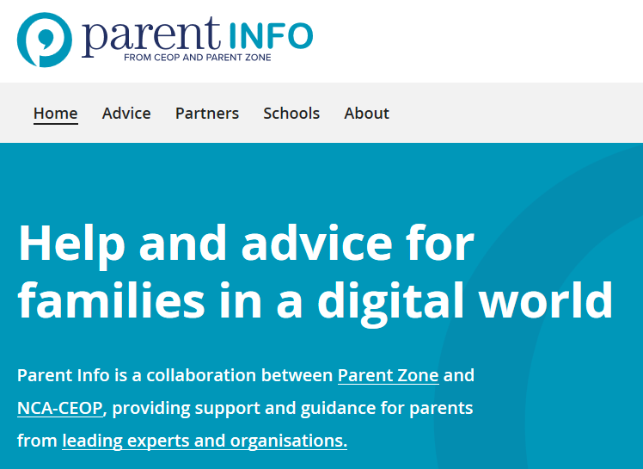
https://esafety.gov.au/complaints-and-reporting/cyberbullying-complaints/social-media-services-safety-centres
A guide to every social media app includes links for reporting, policies and key information.

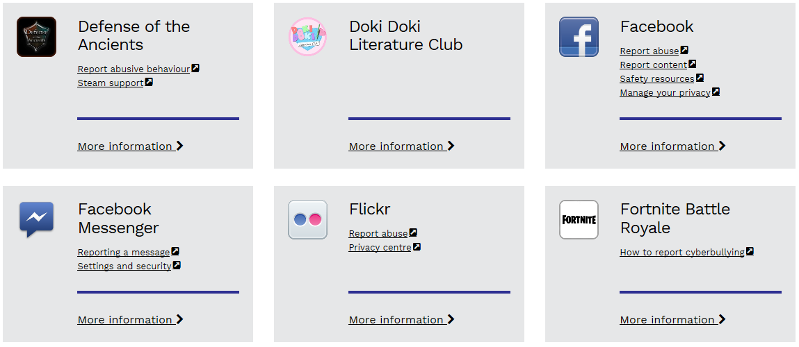

http://www.phonebrain.org.uk/top-tips/
Information for parents/children on how to stay in control of their phones.
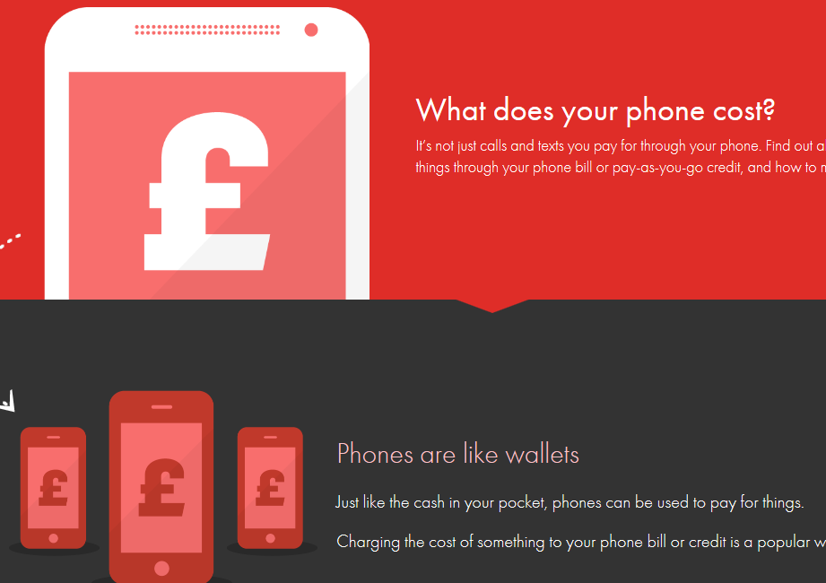

https://www.internetmatters.org/
Helping parents keep their children safe online.
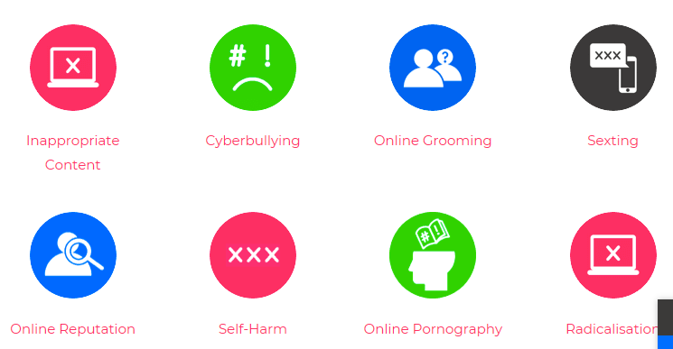

https://www.bbc.com/ownit
http://www.bbc.co.uk/webwise/0/
Very current help and advice for children.
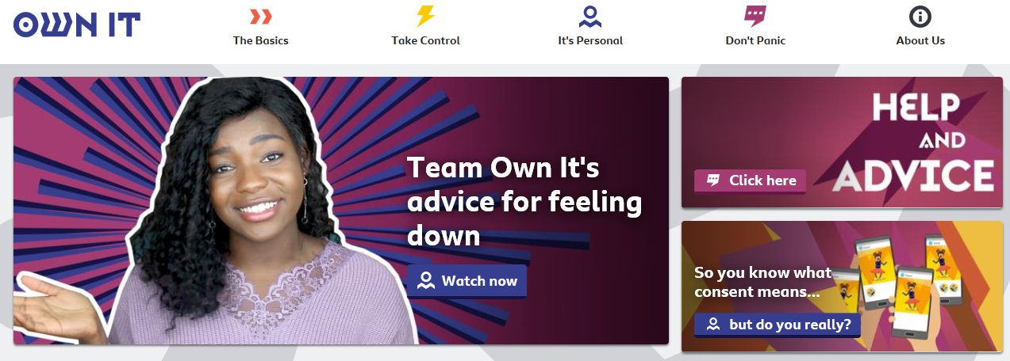

https://www.childnet.com/


