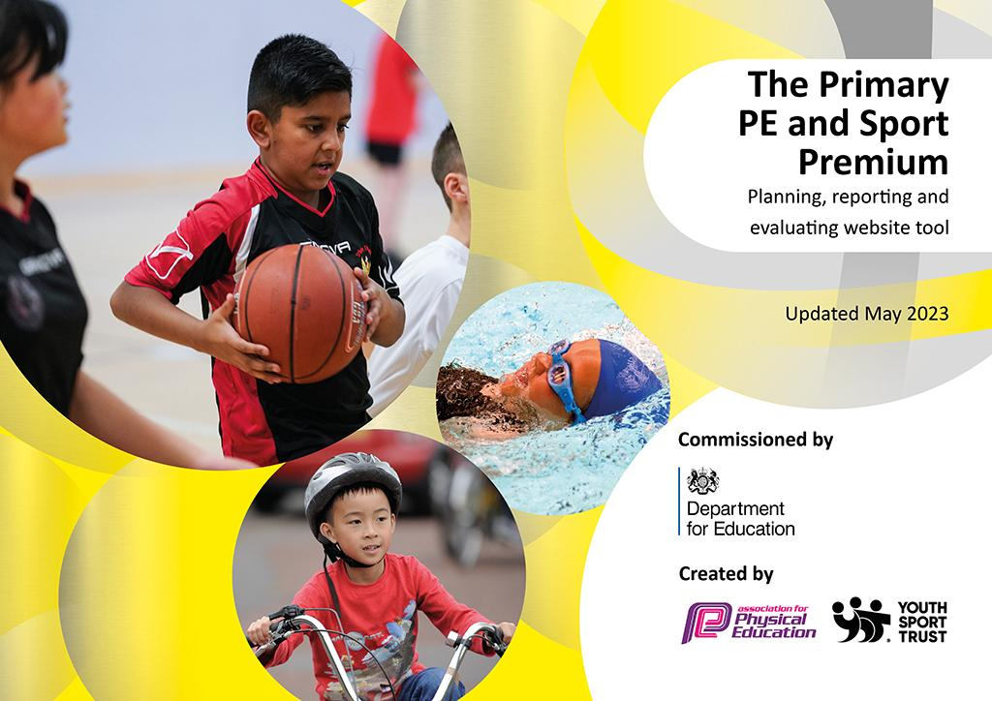
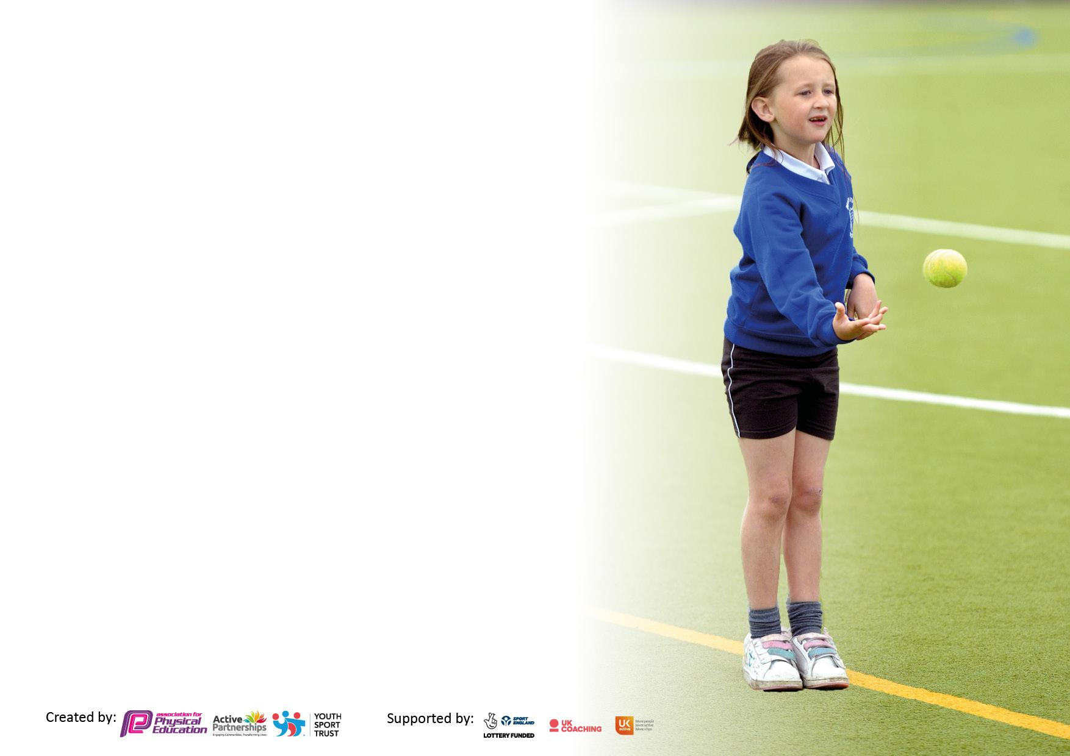

It is important that your grant is used effectively and based on school need. The Education Inspection Framework makes clear there will be a focus on ‘whether leaders and those responsible for governors all understand their respective roles and perform these in a way that enhances the effectiveness of the school’.

Under the Quality of Education Ofsted inspectors consider:
Intent - Curriculum design, coverage and appropriateness
Implementation - Curriculum delivery, Teaching (pedagogy) and Assessment
Impact - Attainment and progress

To assist schools with common transferable language this template has been developed to utilise the same three headings which should make your plans easily transferable between working documents.

Schools must use the funding to make additional and sustainable improvements to the quality of Physical Education, School Sport and Physical Activity (PESSPA) they offer. This means that you should use the Primary PE and sport premium to:

- Develop or add to the PESSPA activities that your school already offer
- Build capacity and capability within the school to ensure that improvements made now will benefit pupils joining the school in future years
- The Primary PE and sport premium should not be used to fund capital spend projects; the school’s budget should fund these.

Pleasevisitgov.ukfortherevisedDfEguidanceincludingthe5keyindicatorsacrosswhichschoolsshoulddemonstrate animprovement.Thisdocumentwillhelpyoutoreviewyourprovisionandtoreportyourspend.DfEencouragesschools to use this template as an effective way of meeting the reporting requirements of the Primary PE and Sport Premium.

We recommend you start by reflecting on the impact of current provision and reviewing the previous spend.

Schools are required to publish details of how they spend this funding, including any under-spend from 2021/2022, as well as on the impact it has on pupils’ PE and sport participation and attainment. All funding must be spent by 31st July 2023.

We recommend regularly updating the table and publishing it on your website throughout the year. This evidences your ongoing self-evaluation of how you are using the funding to secure maximum, sustainable impact. Final copy must be posted on your website by the end of the academic year and no later than the 31st July 2023. To see an example of how to complete the table please click HERE.
Details with regard to funding
Please complete the table below.

Total amount carried over from 2021/22 | £ 0
Total amount allocated for 2021/22 | £ 0
How much (if any) do you intend to carry over from this total fund into 2022/23? | £ 0
Total amount allocated for 2022/23 | £21,600
Total amount of funding for 2023/23. To be spent and reported on by 31st July 2023. | £21,600
Swimming Data
Please report on your Swimming Data below.

Meeting national curriculum requirements for swimming and water safety.

N.B. Complete this section to your best ability. For example you might have practised safe self-rescue techniques on dry land which you can then transfer to the pool when school swimming restarts.
Due to exceptional circumstances priority should be given to ensuring that pupils can perform safe self rescue even if they do not fully meet the first two requirements of the NC programme of study
What percentage of your current Year 6 cohort swim competently, confidently and proficiently over a distance of at least 25 metres?  N.B. Even though your pupils may swim in another year please report on their attainment on leaving primary school at the end of the summer term 2022.  Please see note above | 82%
What percentage of your current Year 6 cohort use a range of strokes effectively [for example, front crawl, backstroke and breaststroke]?  Please see note above | 82%
What percentage of your current Year 6 cohort perform safe self-rescue in different water-based situations? | TBC%
Schools can choose to use the Primary PE and sport premium to provide additional provision for swimming but this must be for activity over and above the national curriculum requirements. Have you used it in this way? | Yes

Action Plan and Budget Tracking
Capture your intended annual spend against the 5 key indicators. Clarify the success criteria and evidence of impact that you intend to measure to evaluate for pupils today and for the future.

Academic Year: 2022/23 | Total fund allocated: £21,600 | Date Updated: July 23
Key indicator 1: The engagement of all pupils in regular physical activity – C3hief Medical Officers guidelines recommend that primary school pupils undertake at least 30 minutes of physical activity a day in school |  |  |  | Percentage of total allocation:
 |  |  |  | 0%
Intent | Implementation |  | Impact
Your school focus should be clear what you want the pupils to know and be able to do and about  what they need to learn and to  consolidate through practice: | Make sure your actions to achieve are linked to your intentions: | Funding allocated: | Evidence of impact: what do pupils now know and what can they now do? What has changed?: | Sustainability and suggested next steps:
- Continue to develop and enhance OPAL (outside play and learning). Purchase of new climbing wall equipment.. Pupils consider their own risk and make appropriate choices. Development of both fine and gross motor skills | - Engaging pupils in lots of different and interesting activities during break times and lunch times.  - Regular assemblies and lessons held to explore the idea of risk. To encourage pupils to consider their own risk and make appropriate choices. | Allocated £0  Spent £4260 (agreed 21/22) | - Engaging pupils in lots of different and interesting activities during break times and lunch times.  - Regular assemblies and lessons held to explore the idea of risk. To encourage pupils to consider their own risk and make appropriate choices. | - All staff are trained. A team has been formed to continue the development of this programme over the next and future years.
Key indicator 2: The profile of PESSPA being raised across the school as a tool for whole school improvement |  |  |  | Percentage of total allocation:
 |  |  |  | 1%
Intent | Implementation |  | Impact
Your school focus should be clear what you want the pupils to know and be able to do and about  what they need to learn and to  consolidate through practice: | Make sure your actions to achieve are linked to your intentions: | Funding allocated: | Evidence of impact: what do pupils now know and what can they now do? What has changed?: | Sustainability and suggested next steps:
- Continued subscription to CPD for PE Lead.  - Class/celebration assemblies take place regularly to ensure whole school awareness of the importance of PE and Sport and Physical activity within school life and to encourage all pupils to aspire to being involved. Badges, certificates, photos of teams and Trophies given out and children reflect on what they achieved.  - Regular use of twitter to inform the school community of the different activities and results the school has achieved. Half Termly PE & Sports newsletter produced and sent out to the whole school community. | - Continuing to address whole school staff professional development. PE termly subject leader meetings.  - Achievements celebrated in assembly highlighting match results, notable achievements in competition and what the pupils are doing in PE lessons throughout the year.  - Achievements celebrated via twitter and in half termly PE & Sports newsletter highlighting what is happening at HPS to the whole school community. | Allocated £270  Spend to date £270 | - PE leader attendance at quarterly meetings, updating and networking.  - All pupils attend class/celebration assemblies. Inspiring all pupils to be involved in sport/physical activity.  - Whole school community sent out a PE & Sports newsletter half termly, also held on the website, sports notice board and regular twitter feeds. | - Ensures sustainability in the planning, monitoring and continuous development of HQ PE and sport.  - Raised profile throughout the whole school. Sustainable if the PE and Sports Premium discontinued.  - SLT have seen benefits of the raised profile and is committed to this area.

Key indicator 3: Increased confidence, knowledge and skills of all staff in teaching PE and sport |  |  |  | Percentage of total allocation:
 |  |  |  | 106%
Intent | Implementation |  | Impact
Your school focus should be clear | Make sure your actions to | Funding | Evidence of impact: what do | Sustainability and suggested
what you want the pupils to know | achieve are linked to your | allocated: | pupils now know and what | next steps:
and be able to do and about | intentions: |  | can they now do? What has
what they need to learn and to |  |  | changed?:
consolidate through practice:
- Improve progress and achievement of all pupils with focus on up-skilling all staff from team teaching with a specialist PE teacher/coach  - The curriculum is broad for all key stages. A curriculum map for PE has been drawn up and reviewed annually to map out the provision for all year groups; this enables a wide range of activities being offered and clear progression through the different year groups.  - Continued introduction of external local sports clubs to teach specific sports in PE lessons and extra-curricular lessons throughout the year.  - Staff confident to run lunchtime clubs and take pupils out to other schools for competitions  - Purchase of REAL PE new scheme of work which will enable teachers to participate in further quality CPD to improve confidence, knowledge and skills in teaching PE from September 23. | - Monday-Friday morning/afternoon curriculum PE, team teaching by specialist PE teacher with class teachers/teaching assistants from all Key stages increasing knowledge, skills and confidence of Teachers and TA’s.  - PE & Sports curriculum map is reviewed annually making sure it is relevant for the key stages/year groups. Competition timetables are consulted to help decide what is needed to be taught and when. This also allows the introduction of new skills and sports where appropriate.  - Inviting local external clubs with specialist coaches to come into school and team teach and talent spot. RAW tennis 6 weeks per term for EYFS & KS1 as well as 1 week of Yr3,4&5 SEND pupils for extra-curricular tennis. Hayes CC through a chance to shine programme for 6 weeks in the Summer term for Yr4.  - Teachers' knowledge and confidence increased by running clubs and taking pupils out of school to different competitions.  - Teachers participate in quality CPD to improve confidence, knowledge and skills. My learning is an interactive online training programme for all teachers to undertake in their own time. Plus 1 day of modeled lessons for some. | Allocated £22,871.04  Spend to date £15,901.20  Allocated  £2,290  Spend to date  £2,290 | - HQ PE & Sport teaching and learning for all pupils. Staff mentoring to enable increased confidence and ability to deliver curricular lessons to the HQ required  - Teachers/TA’s follow the curriculum map to allow progression through the year groups. This has allowed pupils to develop their skills and knowledge and become physically literate. This is recorded through assessment during each topic throughout the year.  - Teachers/TA’s knowledge of particular sports increased. Pupils introduced to local external clubs where they can join and develop within a known environment.  - Free sports club offered to pupils run by teachers: boys football, girls football, netball cricket, Athletics and Cross country.  - All teachers will complete REAL PE. My learning by September 23. Some teachers and PE leads will undertake 1 day of modelled lessons with PE lead to continue with in house CPD/training for all teachers. | - Whilst funding continues, increase staff confidence and knowledge in PE and Sport.  - This will lead to sustainability as all staff are well supported and feel confident to deliver PE & Sport.  - Fully sustainable as systems are in place for information to be reviewed on an annual basis  - This is sustainable as links with the external clubs are now fully established.  - This is sustainable as staff undertaking clubs are supported by specialist PE teacher/coach giving them the confidence to deliver sport outside curriculum time.  - Delivery of high quality PE by all teachers.
Key indicator 4: Broader experience of a range of sports and activities offered to all pupils |  |  |  | Percentage of total allocation:
Intent | Implementation |  | Impact
Your school focus should be clear | Make sure your actions to | Funding | Evidence of impact: what do | Sustainability and suggested
what you want the pupils to know | achieve are linked to your | allocated: | pupils now know and what | next steps:
and be able to do and about | intentions: |  | can they now do? What has
what they need to learn and to |  |  | changed?:
consolidate through practice:
Additional achievements:  - Continue to offer a wide range of activities both within and outside the curriculum in order to get more pupils involved  - More pupils are able to join before school and lunchtime clubs for free.  - Continue to introduce and run further before/lunchtime and after school clubs/activities. | - PE Pupil voice undertaken with all year groups. Children questioned about their learning, describing what they have been taught in lessons, looking at vocabulary relating to the lesson and progression through the years. | (see KI 3) | - Different sports within curriculum time taught throughout the year allowing KS2 pupils to take part in and develop their skills within their PE lessons. Every pupil tries a sport they might not otherwise participate in. For example, netball, basketball, volleyball, tag rugby, tennis, hockey, cricket, athletics, skipping, dodgeball, rounders.  - Over 35+ Yr3/4/5/6 pupils regularly attend Cross Country Club on a Tuesday morning with 68 pupils registered for the club and a waiting list.  - 20 Yr6/5 girls attended Girls Football club on a Wednesday lunchtime. With a waiting list for more wanting to join.  - 23 Yr6 boys/girls attended mixed netball club.  - 29 Yr6 boys/girls attended lunchtime cricket club  - 25 Yr6 boys/girls attended lunchtime tag rugby club.  - Continued links with local community sports/leisure providers for example RAW Tennis, Hayes CC, Pettswood FC, Bromley Junior FC, Old Wilsonians, Becchamian RFC. Giving the opportunity for pupils to progress in the sport of their choice within a more professional environment.  Wider Impact As A Result of the Above  - Pupils' progress and achievement in curriculum PE is very good. Lower key stage pupils see what is offered to higher KS pupils and want to join clubs at a younger age. | - Continued up skilling of teaching staff in new and existing activities.  - Equipment checked and audited regularly and purchased when necessary.  - More new sports clubs to be formed.

Key indicator 5: Increased participation in competitive sport |  |  |  | Percentage of total allocation:
 |  |  |  | 5%
Intent | Implementation |  | Impact
Your school focus should be clear | Make sure your actions to | Funding | Evidence of impact: what do | Sustainability and suggested
what you want the pupils to know | achieve are linked to your | allocated: | pupils now know and what | next steps:
and be able to do and about | intentions: |  | can they now do? What has
what they need to learn and to |  |  | changed?:
consolidate through practice:
- Increase range of physical activities/sports incorporated into curricular and extra-curricular provision  - Increased number of pupils wanting and able to participate in sport specific inter school competitions.  - Non-swimmers achieve 25 meters thus meeting the statory requirement of the National Curriculum of PE. Priority giving ensuring pupils can perform safe –rescue. | - Specialist PE teacher/coach delivers before school and lunchtime clubs and afterschool sports matches  - Attend SGO organised and non SGO competitions. Enhance working links with local clubs  - Membership to borough SGO Interschool competition package including Athletics and completing School games mark (Platinum)  - Bromley Primary Schools Cross Country Association  - Top-up swimming lessons course July 10 for 5 pupils with Aquakids/Swim England. | See KI 3 for details  Allocated  £990  Spend to date  £750  £240  Allocated  £175  Spend to Date  £175 | - 10 Yr5/6 girls attended football tournament at CPFC new academy- finishing 2rdin their group  - 10 Yr6 boys attended a football tournament at CPFC new academy – finishing 1st in their group going through to the Primary Stars finals to play schools from Bromley/Croydon and Sutton boroughs.  - 15 Yr6 boys/ girls attended the High5 competition. Taking 2 teams. A team finished 1st in group and went onto H5 finals where they finished 4th overall in the borough  - 40 Yr3/4/5/6 boys and girls attended Cross Country Competition with very good team and individual results.  - 2 children represented Bromley at LYG Cross Country.  - 19 Yr6 boys/girls attended Sports Hall Athletics competition finishing joint 4th overall in the borough  - 21 Yr4/5/6 boys/girls attended the Swimming gala finishing 2nd overall best ever position.  - 8 Yr5 boys/girls attended a Tag Rugby competition. Finished 3/8  - 19 Yr6 boys/ girls attended Tag Rugby competition. Taking 1 main team and 1 development team. MT finished 4/20  - 8 Yr1/2 boys/girls attended the Easter Bunny Run. Superb individual results and teams finished 3/10 overall  - 10 Yr5/6 boys/girls attended Quad Kids competition. Finished 5/12 schools overall.  - 10 Yr3/4 boys/girls attended Quad Kids competition. Finished 6/10 schools overall.  - 9 Yr5/6 boys/girls attended Boys cricket competition. Finished 5/18 schools overall.  - 9 Yr5/6 girls attended Girls cricket competition.  - 24 Yr5/6 boys/girls attended Large School Athletics competition. Finishing 2/13 schools, just 1 point behind 1st place! 10 pupils qualified for the individual competition.  - 10 Yr5 girls attended a football festival.  - 40+ Yr5/6 boys and girls taking part in district league and cup football matches throughout the school year.  Wider Impact As A Result of the Above  - Improved standards in PE  - More girls are keen to take part with a noticeable difference in attitudes to PE and Sport.  - To achieve a higher percentage of pupils able to swim 25 meters by the end of Year 6 and perform safe self rescue.

Signed off by
Head Teacher:
Date:
Subject Leader: | Sue Swift
Date: | July 2023
Governor:
Date:

